National University of Computer and Emerging Sciences



Lab Manual

for

Programming Fundamentals

|  |  |
| --- | --- |
| Course Instructor | Mr. Owais Idrees |
| Lab Instructor(s) | Ms. Abiha Aftab  Ms. Muntaha Zaigham |
| Section | PF J |
| Semester | Fall 2021 |

Department of Computer Science

FAST-NU, Lahore, Pakistan

# INTRODUCTION

## C++ functions

Function Syntax:

return_type function_name (parameter list) {

body of the function

}

Here,

* **Return Type** − A function may return a value. The **return_type** is the data type of the value the function returns. Some functions perform the desired operations without returning a value. In this case, the return_type is the keyword **void**.
* **Function Name** − This is the actual name of the function. The function name and the parameter list together constitute the function signature.
* **Parameters** − A parameter is like a placeholder. When a function is invoked, you pass a value to the parameter. This value is referred to as actual parameter or argument. The parameter list refers to the type, order, and number of the parameters of a function. Parameters are optional; that is, a function may contain no parameters.
* **Function Body** − The function body contains a collection of statements that define what the function does

Reference: https://www.tutorialspoint.com/cplusplus/cpp_functions.htm

## Flowchart of functions in C++

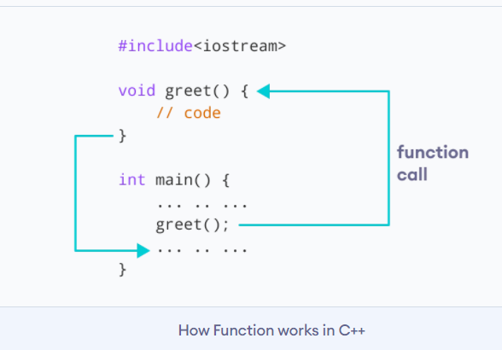

### Example 1: Printing Hello World using a function

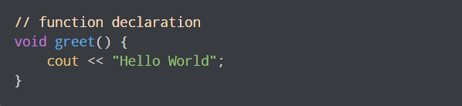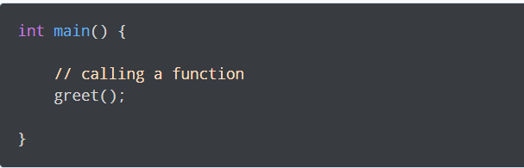

Example:

/ C++ program to illustrate

#include <iostream>

using namespace std;

void func(int a, int b)

{

    a += b;

    cout <<"In func, a = " << a << " b = "<< b << endl;

}

int main(void)

{

    int x = 5, y = 7;

    // Passing parameters

    func(x, y);

    cout << "In main, x = " << x << " y = " << y;

    return 0;

}

# Lab Manual 08

## Problem 1 (for-loop):

## Write a program to find greatest common divisor (GCD) or highest common factor (HCF) of given two numbers.

Problem 2**:**

## Write a program to print the factorial of a number by defining a function named 'Factorial'. Factorial of any number n is represented by n! and is equal to 1*2*3*....*(n-1)*n. E.g.- 4! = 1*2*3*4 = 24 3! = 3*2*1 = 6 2! = 2*1 = 2 Also, 1! = 1 0! = 0

## Take the number n as input and pass it as the parameter in function from user and print the output.

Problem 3:

## Write a function that counts and display the number of digits present in an integer number entered by user.

Example: 12345 contains 5 digits.

Problem 4:

## Write a function that takes a number entered by user and tell if the sum of first half of the number equals the sum of second half of the same number.

Example:

## Number entered: 123330

## Sum of first half: 1+2+3 = 6

## Sum of second half: 3+3+0=6

## Result: true

## Number entered: 12030

## Sum of first half: 1+2+0 = 3

## Sum of second half: 3+0=3

## Result: true

Problem 5:

## Write a function that takes a number entered by user and tell if both halves of the number are divisible by 11 or not.

Example:

## Number entered: 123321

## First half= 123

## Second half= 321

## Result: false

## Number entered: 3344

## First half= 33

## Second half=44

## Result: true